# 

ERASMUS+ project **“Transformative Digital Pedagogies for Higher Education”   
contract Nr**. **2022-1-LV01-KA220-HED-000085277** **t**

**REPORT**

**WP2: Theoretical and empirical framework of transformative digital pedagogical competences**

**WP2.7 Presenting TDP4HE self-assessment framework: Hybrid event (E1) (Riga)**

**Coordinator:** RTU, Latvia

**Author of report:** Olga Vindača

February 2024

**TABLE OF CONTENTS**

|  |  |
| --- | --- |
| Introduction ……………………………………………………………….  Description of Hybrid Event ……………………………………………...  Appendix 1 – Event Agenda  Appendix 2 - Final Framework  Appendix 3 – List of Participants  . | 3  4 |
|  |  |

**INTRODUCTION**

The purpose of this report is to reflect the Hybrid event held on 06th of February 2024 both online/ offline for presenting the final framework for the assessment of transformative digital pedagogical competence of academic staff, based on the results gained within the already conducted activities:

- activity WP2 - A2.1 Overview of assessment frameworks;

- activity WP2 -A2.2 Creating data collection instruments for the co-creation of the self-assessment framework and its evaluation;

- activity WP2 – A2.3 Creating a focus group for the co-construction of the new self-

assessment framework on transformative digital pedagogies;

- activity WP2 – A2.4 Developing the TDP4HE self- assessment framework

- activity WP2 – A2.5 Producing the TDP4HE self-assessment framework e-Tool.

**DESCRIPTION OF HYBRID EVENT**

Date: 06th of February 2024

Time: 14.00-16.00 (CET)

Place: online/offline

Participants: 53 participants from Latvia, Spain, Ireland, Cyprus and France (list of participants is presented in Appendix 3).

Agenda: presented in Appendix 1.

A2.7: Hybrid event (E1). The event was organised as an open workshop with an introduction to the TDP4HE self- assessment framework (Appendix 2), followed by a hands-on session where the participants will learn how to use the self-assessment

Following the A2.7, the testing of self-assessment e-tool was conducted (A2.6).

**Appendix 1**

**ERASMUS+ project “Transformative Digital Pedagogies for Higher Education”   
contract Nr. 2022-1-LV01-KA220-HED-000085277 t**

**WP2: Theoretical and empirical framework of transformative digital pedagogical competences**

**AGENDA**

**Hybrid Event (E1)**

***February 6th, 2024***

14.00 – 16.00 CET

Microsoft Teams Platform/RTU

|  |  |  |
| --- | --- | --- |
| **14.00** | Short introduction into ERASMUS+ project **“Transformative Digital Pedagogies for Higher Education”** | RTU |
| **14.10** | Presentation of TDP4HE self-assessment framework (A2.7) | RTU |
| **14.40** | SUMMARY | All Participants |
| **14.50** | Introduction to TDP4HE self-assessment framework e-tool | RTU |
| **15.00** | Filling-in the TDP4HE self-assessment framework e-tool for testing (A2.6)  Explaining the statements and scaling | RTU |
| **15.15** | Participants fill-in TDP4HE self-assessment framework e-tool individually  In case of necessity the explanations can be provided | All Participants |
| **15.30** | Explanation of TDP4HE self-assessment framework e-tool assessment results | RTU |
| **15.45** | Conclusion / summary | All Participants |

**Appendix 2**

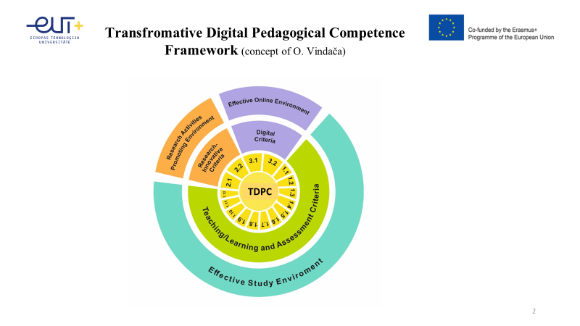

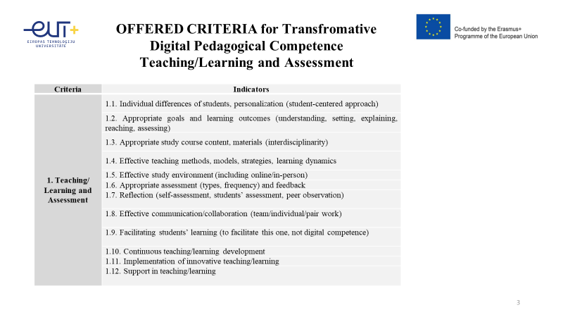

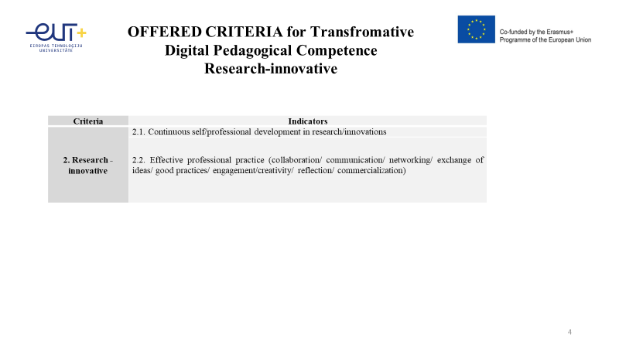 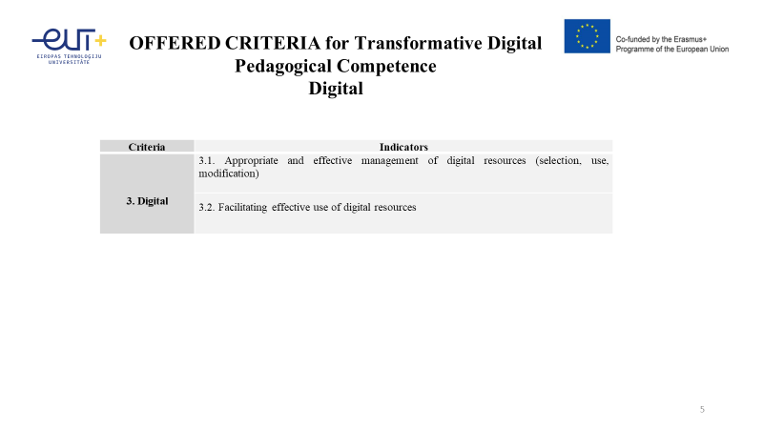

**Appendix 3**

ERASMUS+ project **“Transformative Digital Pedagogies for Higher Education”   
contract Nr**. **2022-1-LV01-KA220-HED-000085277** **t**

**WP2: Theoretical and empirical framework of transformative digital pedagogical competences**

**Hybrid Event (E1)**

**Participants**

***February 6th, 2024***

14.00 – 16.00 CET

Microsoft Teams Platform/RTU

Organizer: Riga Technical University, Latvia

|  |  |  |  |
| --- | --- | --- | --- |
| **Nr.** | **Name, Family name** | **Org.** | **e-mail** |
| 1 | Aina Strode | RTA | aina.strode@rta.lv |
| 2 | Alejandro Martínez Sala | UPCT | Alejandros.martinez@upct.es |
| 3 | Alona Klodane | RTA | alona.klodane@rta.lv |
| 4 | Anda Abolina | RTA | anda.abolina@rta.lv |
| 5 | Andina Sprince | RTU | Andina.sprince@rtu.lv |
| 6 | Anna Mutule | RTU | Anna.matule@rtu.lv |
| 7 | Antonio Juan Briones Peñalver | UPCT | Aj.briones@upct.es |
| 8 | Atiq Ahmed | UTT | Atiq.ahmed@utt.fr |
| 9 | Aurelien Benel | UTT | Aurelien.benel@utt.fr |
| 10 | Dmitrijs Serdjuks | RTU | Dmitrijs.serdjuks@rtu.lv |
| 11 | Eleanor Asprey | UTT | Eleanor.asprey@utt.es |
| 12 | Elis Constantinou | CUT | Elis.constantinou@cut.ac.cy |
| 13 | Enrique Castro Rodríguez | UPCT | Enrique.castro@upct.es |
| 14 | Eriks KJavins | RTU | Eriks.klavins@rtu.lv |
| 15 | Eva Martínez Caro | UPCT | Eva.martinez@upct.es |
| 16 | Eva Martínez García | UPCT | Eva.martinezg@upct.es |
| 17 | Francisco Javier Cánovas Rodríguez | UPCT | FcoJavier.canovas@upct.es |
| 18 | Francisco Vera García | UPCT | Francisco.vera@upct.es |
| 19 | Gonzalo García Ros | UPCT | Gonzalo.garcia@upct.es |
| 20 | Gunars Strods | RTA | gunars.strods@rta.lv |
| 21 | Gundars Alksnis | RTU | Gundars.alksnis@rtu.lv |
| 22 | Hadji Constantinou | CUT | s.hadjiconstantinou@cut.ac.cy |
| 23 | Ilze Birzniece | RTU | Ilze.birzniece@rtu.lv |
| 24 | Ilze Bodza | RTA | ilze.bodza@rta.lv |
| 25 | Inese Novica | RTA | Inese.novika@rta.lv |
| 26 | Irēna Beinarovica- Litvinova | RTA | irena.beinarovica-litvinova@rta.lv |
| 27 | Janis Dzerviniks | RTA | Janis.dzerviniks@rta.lv |
| 28 | Juan Ángel Pastor Franco | UPCT | Juanangel.pastor@upct.es |
| 29 | Juan Patricio Castro Valdivia | UPCT | Juanpatricio.castro@upct.es |
| 30 | Juan Ruíz Alvarez | UPCT | Juan.ruiz@upct.es |
| 31 | Konstantins Kozlovskis | RTU | Konstantins.kozlovskis@rtu.lv |
| 32 | Kristine Fedotova | RTU | kristine.fedotova@gmail.com |
| 33 | Laura Vitola | RTU | Laura.vitola_1@rtu.lv |
| 34 | Liga Daniläne | RTA | Liga.danilane@rta.lv |
| 35 | Liliana Pravarne | RTU | liliana.pravarne-statkus@rtu.lv |
| 36 | Lorena Martínez Zamora | UPCT | Lorena.martinez@upct.es |
| 37 | Loreta Juskaite | RTU | Loreta.juskaite@rtu.lv |
| 38 | María del Camino Ramón Llorens | UPCT | Camino.ramon@upct.es |
| 39 | María del Mar García Alcaraz | UPCT | Mar.alcaraz@upct.es |
| 40 | María José Roca Hernández | UPCT | Mjose.Roca@upct.es |
| 41 | María Victoria Soulé | CUT | Mariavictoria.soule@cut.at.cy |
| 42 | Martins Bonders | RTU | Martins.bonders@rtu.lv |
| 43 | Noelia Sánchez Casado | UPCT | Noelia.sanchez@upct.es |
| 44 | Normunds Balabka | RTU | Normunds.balabka@rtu.lv |
| 45 | Olesja Griorjeva | RTU | Olesja.grigorjeva@rtu.lv |
| 46 | Olga Vindača | RTU | Olga.vindaca@rtu.lv |
| 47 | Patrick Flynn | TUDublin | Patrick.flynn@tudublin |
| 48 | Pavels Gavrilovs | RTU | pavels.gavrilovs@rtu.lv |
| 49 | Pilar Manzanares López | UPCT | Pilar.manzanares@upct.es |
| 50 | Roberto Javier Cañavate Bernal | UPCT | r.canavate@upct.es |
| 51 | Silvija Mezinska | RTA | silvija.mezinska@rta.lv |
| 52 | Soledad María Martínez María Dolores | UPCT | Soledad.martinez@upct.es |
| 53 | Velta Lubkina | RTU | Velta.lubkina@rtu.lv |