# 

ERASMUS+ project **“Transformative Digital Pedagogies for Higher Education”   
contract Nr**. **2022-1-LV01-KA220-HED-000085277** **t**

**REPORT**

**Work Package 4.5.   
Presenting the Virtual Community of OER and OEP: Hybrid Event E2 in TU Dublin**

**Analyzing and reporting participants' feedback and recommendations to the TDP4HE self-assessment framework**

**Coordinator:** TU Dublin, Ireland

**Author of report:** Mick Mc Keever

October 2024

**INTRODUCTION**

The purpose of this report is to analyse the feedback from the participants of testing of TDP4HE self-assessment framework e-tools, covering both quantitative and qualitative data.

This report relates to the TDP4HE task A4.5: Presenting the Virtual community of OER and OEP Hybrid event (E2) Dublin which took place in October 2024 in person in TU Dublin Ireland and Online.

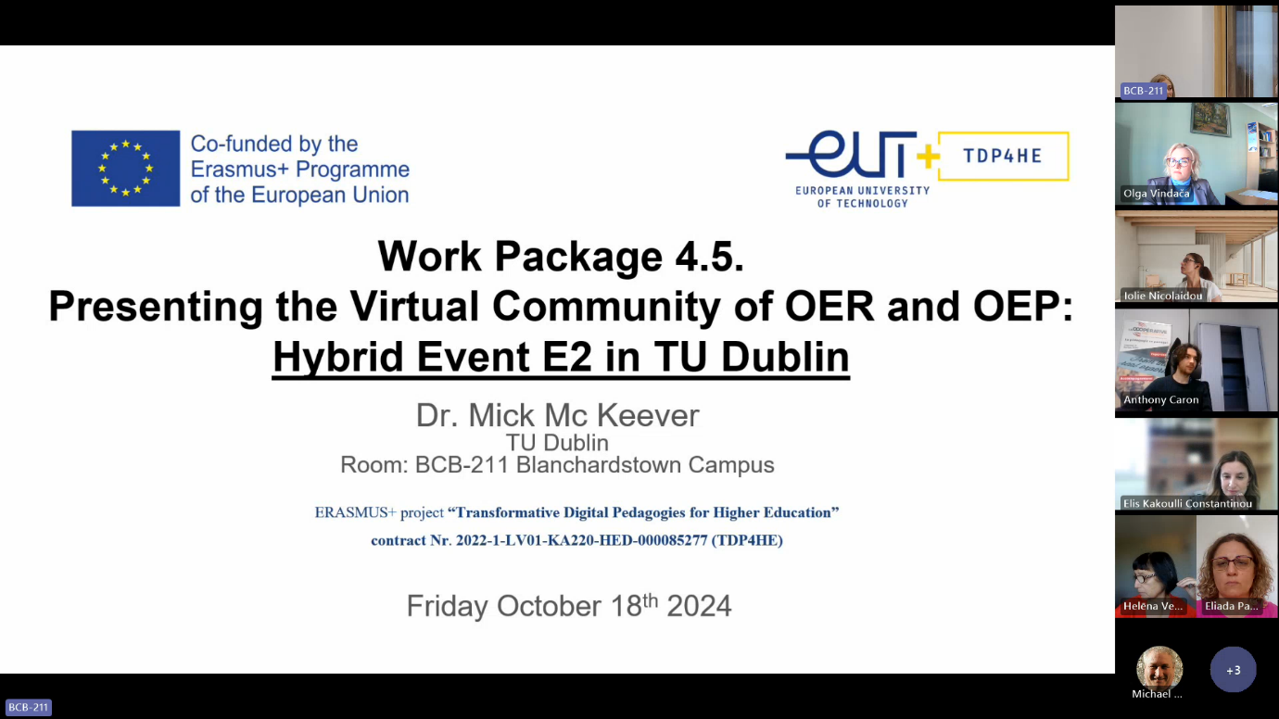

MS Teams was used as the hosting platform in room BCB-211 TU Dublin Ireland, which has full hybrid conference facilities. The following images taking on the day of the hybrid event capture the in person and online aspects. The image on the left below was captured by a participant attending in person, while the image on the right was captured from room BCB-211 computer’s camera.

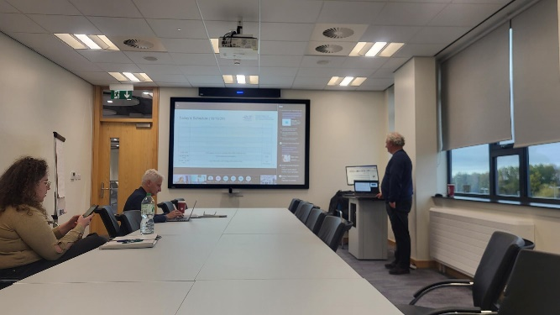 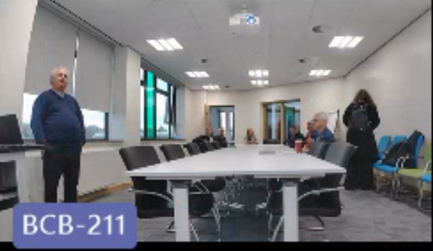

Some of the participants chose to activate their computer cameras as seen in the screenshot below, while the other participants seen on the right of the screen left their screens off to enhance quality if their internet connections were slow or buffering. 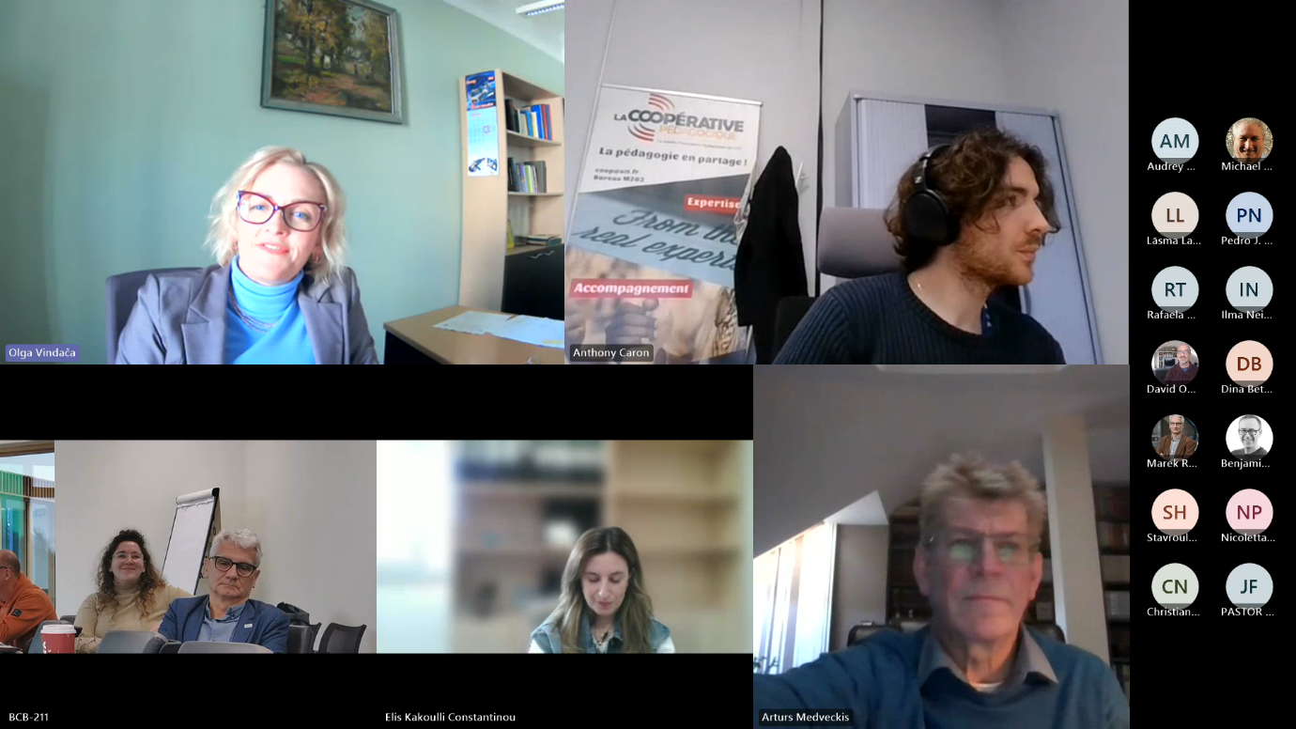

Here is an example of the online view for participants at the start of the event. This is also the same view on the projector screen for in person participants.

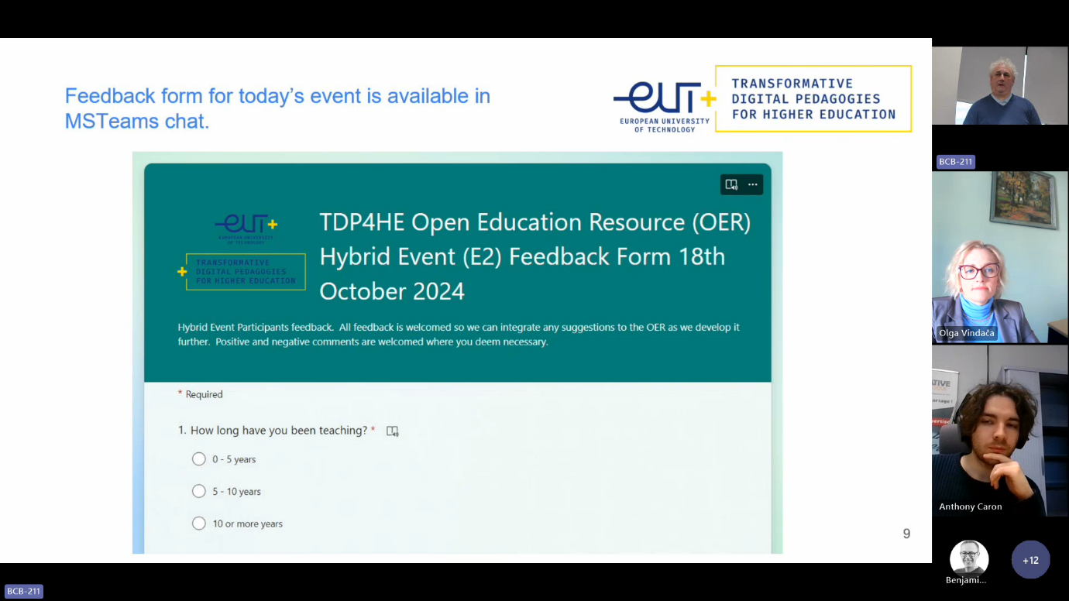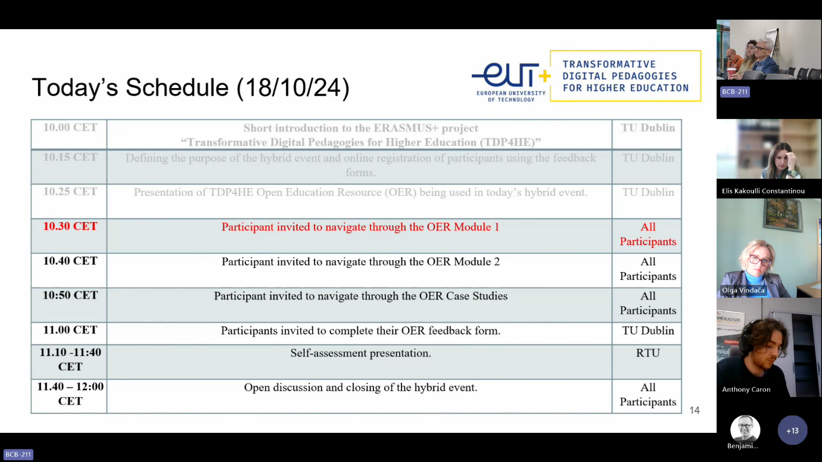

**OVERVIEW OF THE HYBRID EVENT**

The agenda for the hybrid event was presented as follows:

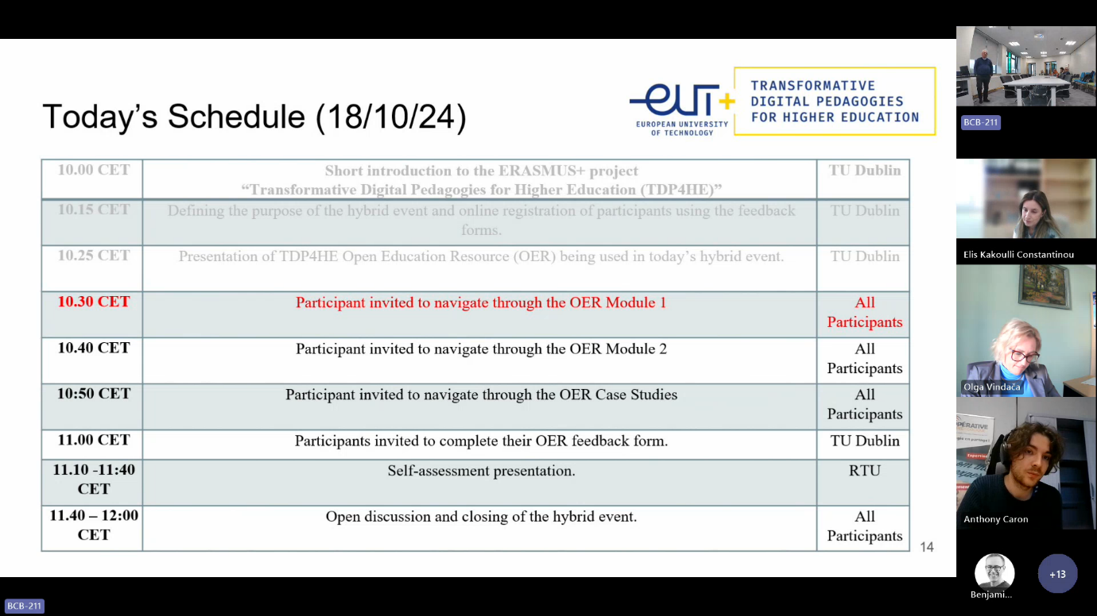

Here are a set of screen shots taken during the event to capture the hybrid



**REGISTERED PARTICIPANTS**

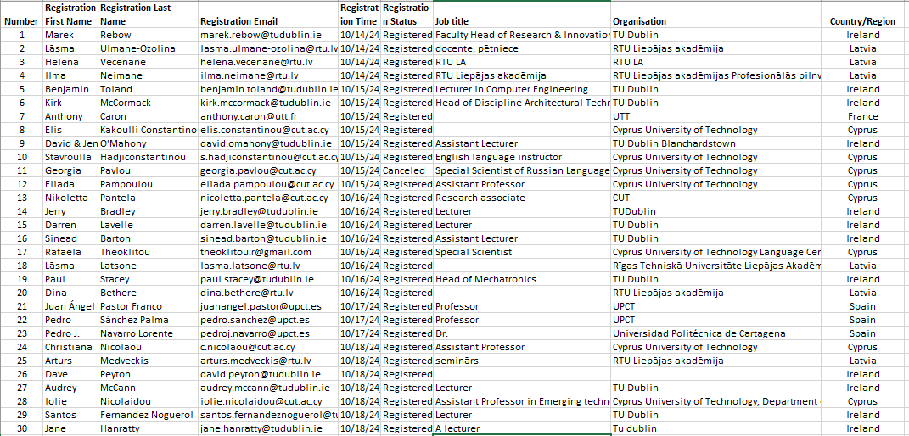

This section presents the quantitative data analysis of self-assessment e-tool responses collected to evaluate transformative digital pedagogical competence of academic staff.

The feedback questions of were formed in accordance to the self-assessment framework for the assessment of transformative pedagogical competence of academic staff.

The total number of participants in the Excel report was 31, with 12 attending in person and the remaining participants attending online.

Figure 1 **Distribution by Country**

One of the important indicators was the occupation of respondents (see Figure 3).

Figure 2 **Distribution by Occupation**

**Feedback Online.**

A Microsoft feedback form was used to gather feedback and each section is summarised in this section. Not all participants provided feedback on the session and it was difficult to get feedback forms completed though time was provided in the agenda.

|  |
| --- |
| **Tell us at least one thing you discovered during the event that will help you with your teaching practice.** |
| Time was too limited to highlight one tool still needs reflection |
| Model 2 |
| The self-assessment E-tool. |
| To self-evaluate TDPC |
| I could use Open Educational Resources platform to see tools I can integrate in my teaching and ways I can do that. |
| That there is a community of practice I can join for support |
| Pedagogical advice behind the use of specific tools |
| Some of the cognitive learning methods were delved into in the videos, very interesting. |
| co-creation of knowledge as a way of developing research projects, community of practice |

Table 1: Sample responses to how the event may impact a participants teaching practice.

The answers in Table 1 show a variety of responses, some participants found the event was delivering a lot of material in a short time frame and perhaps the event could be longer on each individual tool. Others were made aware of the community of practice for the first time and that the event highlighted the work being conducted by TDP4HE project.

|  |
| --- |
| **What did you like most about the OER event?** |
| A lot of information |
| Inspiring ideas |
| Very insightful topics and also well-presented, people attending could keep pace with the event presenter. |
| Feedback of participants |
| I liked the fact that the participants in the event seemed to be interested in developing in terms of transformative digital pedagogies. The event was well-organised, the technologies worked well and everything ran smoothly. |
| Accessible online |
| Very clear and useful content |
| Exposure to the EUT+ initiative and to the resource available. Looking forward to seeing more developments |
| interaction with a presenter and participants, hands on advices how to use Indie4all platform |

Table 2: Feedback on the OER event.

Not all participants responded during the event and as such there may be an element of dissatisfaction that was held back and not captured by the survey. Not all participants completed each section of the feedback form and perhaps the next time this could be improved upon. The participants feedback received is mainly positive and a summary of participants sentiment is captured in Table 2.

|  |
| --- |
| **Do you have any suggestions for us to improve future events as we roll out the OER?** |
| This content should be made more pictoral. The pace and possibilities of perception vary for those participants who are in the room and remotely |
| Share positive experiences |
| To popularize among bigger number of participants |
| No, informative and enjoyable event |
| Some non video activities to participate in e.g. a 10 minute hybrid interactive activity to showcase an item from the OER |
| More detailed presentations of some tools and interactive using of them, |

Table 3: Feedback summary on how we could improve the hybrid event.

Like with the previous feedback question, not all participants chose to answer this question. One of the reasons was because the participants didn’t have much time during the event to reflect and feedback on what they would like to see if the event was run again. This is a flaw in making the participants complete the feedback at the end of the event. Following up with in-person attendees, their feedback was that they would have liked an opportunity to complete feedback about a week after the event, once they have time to reflect while teaching and identify items that may help improve their teaching practice.

|  |
| --- |
| **How would you rank your satisfaction with today OER Hybrid event?** |
| Somewhat satisfied (40-60) |
| Extremely satisfied (80-100) |
| Extremely satisfied (80-100) |
| Very satisfied (60-80) |
| Extremely satisfied (80-100) |
| Very satisfied (60-80) |
| Very satisfied (60-80) |
| Extremely satisfied (80-100) |
| Very satisfied (60-80) |

Table 4: Numerical ranking of participants satisfaction with the hybrid event.

In TU Dublin after the Hybrid event concluded, we had coffee with both tin-person participants and those who were attending online, to compare satisfaction with the event. When asked at the end of the event about their satisfaction with attending in person, those participants seemed far more satisfied than those attending online, as it was easier to get one-to-one direction when assistance was required to navigate the OER.

|  |
| --- |
| **Share with us aspects of the event you did not like.** |
| No objections, good organization |
| The event has been well organized and structured. |
| Again, a bit disruptive when trying to sample video during the event but otherwise great. |

Table 5: Critical feedback from participants on aspects of the hybrid event they didn’t like.

This question in the feedback form had the least answers and this may be attributable to the fact that it is near the end of the feedback form and it is asking for a negative type answer which are easier to ignore for participants.

|  |
| --- |
| **Any other comments or suggestions.** |
| Keep up the good work |
| Thank you!!! |
| I think adding references below the videos, relating to the material in the videos, would be helpful to researchers. |
| If possible, would recommend building in a literature repository under each video covering topics that the video explains. As well to then embed tracking metrics about who is accessing literature through the site. Would attract and keep academics. |
| More information about generative AI in education and relevant tools, and ethical integration of AI in educational assessment. |
|  |

Table 6: Any other suggestions feedback.

This question in Table 6 above was optional in the feedback form but it had more responses than the previous question in table 5.

**End of Session Open Discussion with Participants**

At the end of the hybrid event participants were asked to ask questions and provide input on the topics presented during the event. A summary of these discussions are presented here.

Participants asked about having access to a video of the session so they could revise what was presented in the hybrid event to check over the points made. The general consensus was that they wanted to plan to incorporate the self-assessment and artifacts for a quick start to applying what was presented in the hybrid event to their own teaching practice. The video link of the session was sent to participants post event to facilitate this feedback.

Participants asked for contacts within the group to follow up with e-mail questions on specific topics. One participant suggested a quick way for a novice to get started and how to share the self-assessment with other colleagues who may not have attended. The participants were directed to the links provided in during the hybrid event and support materials for getting started which are open source.

Participants also asked about the time commitment required to complete the process and a general comment was that they should create a plan of what they want to achieve using the resources provided online and make contact through the community of practice for guidance.